A000-Australopithecus afarensis, AL 288-1.

[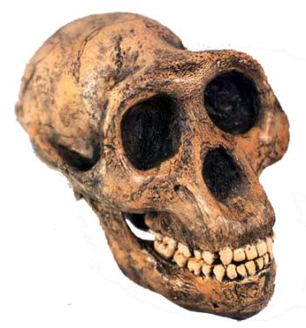](javascript:popUp('newitems/1387.jpg'))

Fig. 1. *Australopithecus afarensis*, AL 288-1, reconstructed cranium, from http://www.prehistoricstore.com/newitems/m1387.jpg.

**Formal Label:** *Australopithecus afarensis*, AL 288-1,

**Display Description:** *Australopithecus afarensis*, is reconstructed from 40% of specimen, AL 288-1, discovered in 1974 at Awash Valley, Hadar Formation, Ethiopia, Afar (Johanson 1981). AL 288-1 is estimated to have lived 3.2 Ma (million years ago). The skeleton shows evidence of a small brain capacity (410 cc) similar to that of apes. However, AL 288-1 was capable of bipedal, upright walking, providing evidence that bipedalism *preceded* increase in brain size in human evolution (Johanson, Lovejoy, Kimbel, White, Ward, Bush, Latimer, and Coppens 1982.).

**Accession Number:**

**LC Classification:** GN283.25

**Date or Time Horizon:** 3.2 Ma

**Geographical Area:** Awash Valley, Hadar Formation, Ethiopia, Afar Zone 3

**Map, GPS coordinates: 9.645567, 40.033001.**

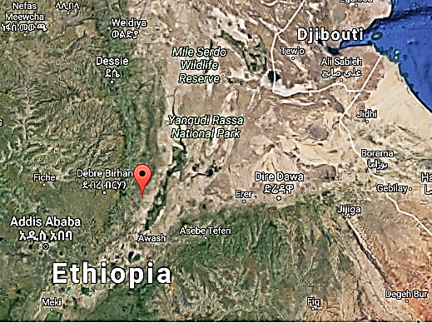 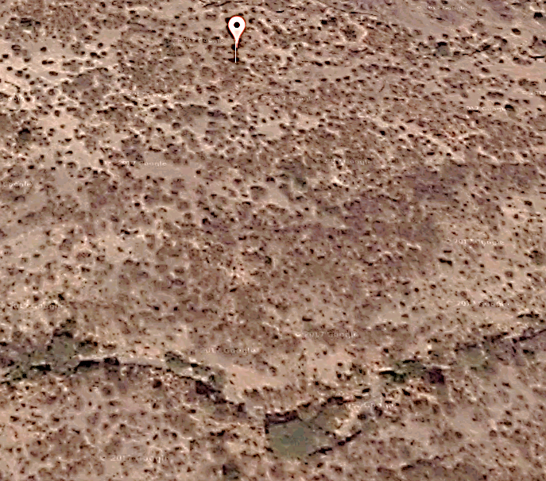

Figs 2-3. Awash Valley, Hadar Formation, Ethiopia, Afar Zone 3.From [**https://maps.google.com/maps/api/staticmap?center=42.47039305%2C-70.88928854999999&zoom=15&size=256x256&language=en&sensor=false&client=google-maps-frontend&signature=ykF5uu0DqoCh08FQ3hRbEpw1Lik**](https://maps.google.com/maps/api/staticmap?center=42.47039305%2C-70.88928854999999&zoom=15&size=256x256&language=en&sensor=false&client=google-maps-frontend&signature=ykF5uu0DqoCh08FQ3hRbEpw1Lik)

**Cultural Affiliation:** *Australopithecus afarensis*

**Medium:** reconstruction of fossil AL 288-1 in resin.

**Dimensions (of cranium of** AL 288-1)**:** H 7.2 in, W 5.2 in, D 5.2 in

**Weight (of** *Australopithecus afarensis)***: 106 lb.**

**Condition: reconstruction from 40% of** AL 288-1**.**

**Provenance:** Paleoanthropology Laboratories of the National Museum of Ethiopia in Addis Ababa, Ethiopia.

**Discussion:** This reconstruction was based on 40% of female fossil AL 288-1, common name “Lucy”. Her upper limbs appear similar to arboreal primates, i.e. chimpanzees, but her lower limb morphology exhibits features typical of habitual bipedalism, suggesting she lived in trees but hunted on foot. The type specimen for *Australopithecus* afarensis is [LH 4](http://efossils.org/page/boneviewer/Australopithecus%20afarensis/LH%204) (Leakey et alii 1976), which was found at Laetoli (Tanzania), and dates between 3.7 and 3.4 Ma (Klein 2009).

**References:**

Johanson. C.J. and Maitland A. Edey. 1981. Lucy, the beginnings of humankind. New York: Simon and Schuster.

Johanson, C.J., C.O. Lovejoy, W.H. Kimbel, T.D. White, S.C. Ward, M.E. Bush, B.M. Latimer, and Y. Coppens. 1982. “Morphology of the Pliocene Partial Hominid Skeleton (AL 288-1) from the Hadar Formation, Ethiopia,” *American Journal of Physical Anthropology,* 57: 403-451.

Klein, R.G. 2009. The Human Career: Human Biological and Cultural Origins. Third Edition. Chicago: University of Chicago Press.

Leakey, M.D., R.L. Hay, G.H. Curtis, R.E. Drake, and M.K. Jackes. 1976. “Fossil hominids from the Laetolil Beds,” *Nature* 262: 460-466